Lab : 13 - Affine Transformation
We take an image and shift, tilt, stretch or shear it by changing the position of 3 points.
Cell 1: Upload Image
from google.colab import files
uploaded = files.upload()

Cell 2: import libraries
import cv2
import numpy as np
import matplotlib.pyplot as plt

cell 3: Read the uploaded image
filename = list(uploaded.keys())[0]
image = cv2.imread(filename)
print("Image uploaded successfully:", filename)

cell 4: Get Image Size
height, width = image.shape[:2]
print("Width:", width)
print("Height:", height)

Cell 5 : Select 3 points and move them
source_points = np.float32([
[50, 50],
[200, 50],
[50, 200]
])

destination_points = np.float32([
[20, 80],
[220, 50],
[80, 220]
])
Cell 6 :
matrix = cv2.getAffineTransform(source_points, destination_points)
print("Affine Matrix:")
print(matrix)
cell 7:
affine_image = cv2.warpAffine(
image,
matrix,
(width, height)
)
Cell 8:
plt.figure(figsize=(10, 5))

plt.subplot(1, 2, 1)
plt.imshow(cv2.cvtColor(image, cv2.COLOR_BGR2RGB))
plt.title("Original Image")
plt.axis("off")

plt.subplot(1, 2, 2)
plt.imshow(cv2.cvtColor(affine_image, cv2.COLOR_BGR2RGB))
plt.title("Affine Transformed Image")
plt.axis("off")

plt.show()
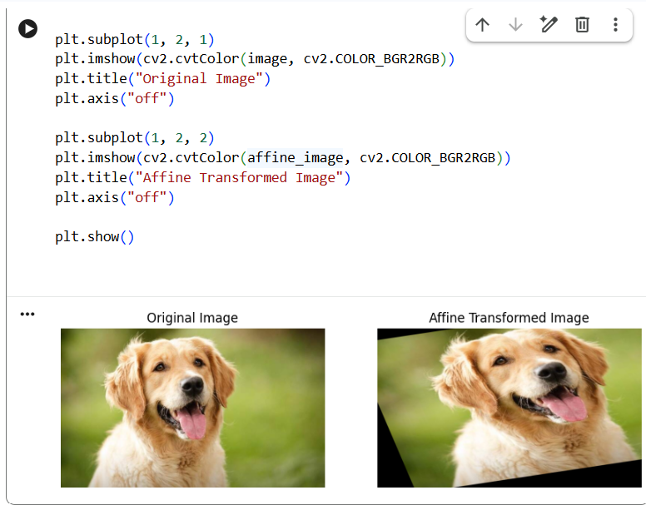

Lab 14 :
Perspective transformation means:
Changing the viewing angle of an image, like making a tilted photo look straight or giving it a 3D-like view. (4 points )

Cell 1: Upload Image
from google.colab import files
uploaded = files.upload()

Cell 2: import libraries
import cv2
import numpy as np
import matplotlib.pyplot as plt

cell 3: Read the uploaded image
filename = list(uploaded.keys())[0]
image = cv2.imread(filename)
print("Image uploaded successfully:", filename)

cell 4: Get Image Size
height, width = image.shape[:2]
print("Width:", width)
print("Height:", height)

Cell 5 : Select 4 points and move them
source_points = np.float32([
[50, 50],
[width - 50, 50],
[50, height - 50],
[width - 50, height - 50]
])

destination_points = np.float32([
[0, 0],
[width, 0],
[100, height],
[width - 100, height]
])
Cell 6 :
matrix = cv2.getPerspectiveTransform(
source_points,
destination_points
)
print("Perspective Matrix:")
print(matrix)
cell 7:
perspective_image = cv2.warpPerspective(
image,
matrix,
(width, height)
)
Cell 8:
plt.figure(figsize=(10, 5))

plt.subplot(1, 2, 1)
plt.imshow(cv2.cvtColor(image, cv2.COLOR_BGR2RGB))
plt.title("Original Image")
plt.axis("off")

plt.subplot(1, 2, 2)
plt.imshow(cv2.cvtColor(perspective_image, cv2.COLOR_BGR2RGB))
plt.title("Perspective Transformed Image")
plt.axis("off")

plt.show()
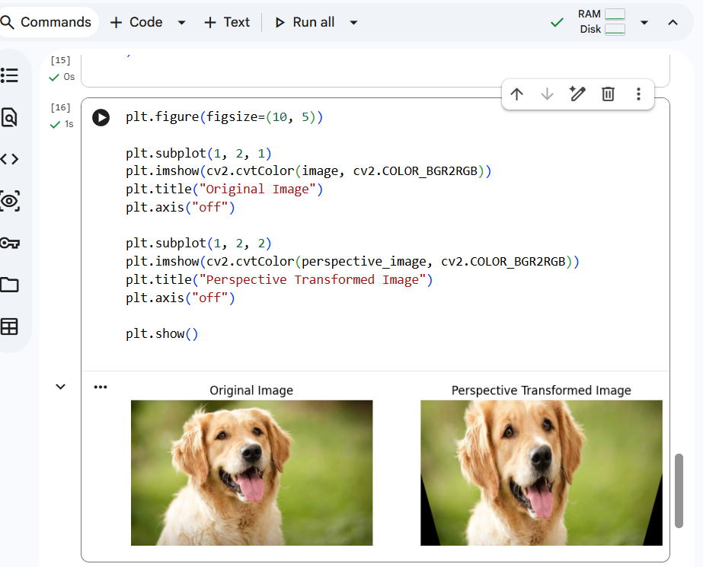

Lab :15 Harris Corner Detection using Python and OpenCV
Harris Corner Detection finds places in an image where the intensity changes strongly in two directions.
from google.colab import files
uploaded = files.upload()

import cv2
import numpy as np
import matplotlib.pyplot as plt

filename = list(uploaded.keys())[0]
image = cv2.imread(filename)
print("Image uploaded successfully:", filename)

gray = cv2.cvtColor(image, cv2.COLOR_BGR2GRAY)

gray = np.float32(gray)

corners = cv2.cornerHarris(
gray,
blockSize=2,
ksize=3,
k=0.04
)

result = image.copy()
result[corners > 0.01 * corners.max()] = [0, 0, 255]

plt.figure(figsize=(10, 5))
plt.subplot(1, 2, 1)
plt.imshow(cv2.cvtColor(image, cv2.COLOR_BGR2RGB))
plt.title("Original Image")
plt.axis("off")
plt.subplot(1, 2, 2)
plt.imshow(cv2.cvtColor(result, cv2.COLOR_BGR2RGB))
plt.title("Harris Corner Detection")
plt.axis("off")
plt.show()

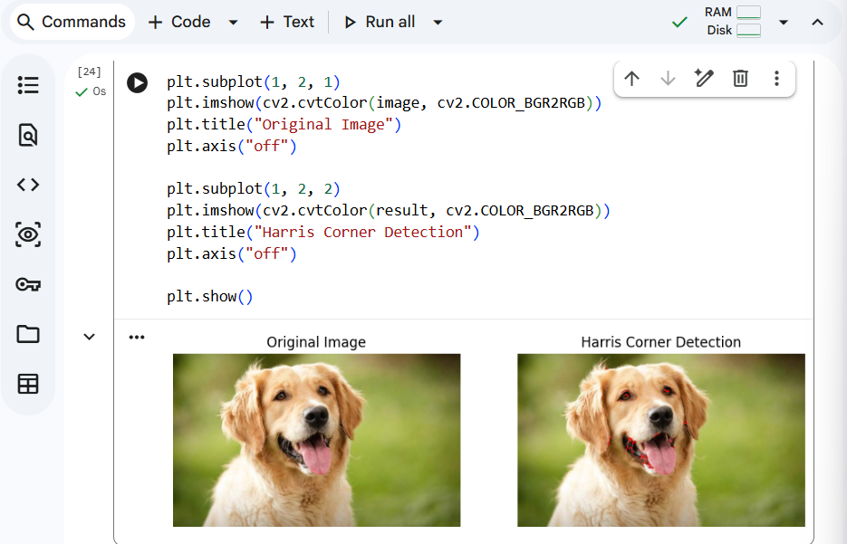

Lab 16 : Implement a Sobel algorithm using Open CV to filter the input image.
from google.colab import files
uploaded = files.upload()

import cv2
import numpy as np
import matplotlib.pyplot as plt

filename = list(uploaded.keys())[0]
image = cv2.imread(filename)
print("Image uploaded successfully:", filename)

gray = cv2.cvtColor(image, cv2.COLOR_BGR2GRAY)

sobel_x = cv2.Sobel(
gray,
cv2.CV_64F,
1,
0,
ksize=3
)

sobel_y = cv2.Sobel(
gray,
cv2.CV_64F,
0,
1,
ksize=3
)

sobel_x = cv2.convertScaleAbs(sobel_x)
sobel_y = cv2.convertScaleAbs(sobel_y)

sobel_combined = cv2.addWeighted(
sobel_x, 0.5,
sobel_y, 0.5,
0
)

plt.figure(figsize=(12, 8))
plt.subplot(2, 2, 1)
plt.imshow(cv2.cvtColor(image, cv2.COLOR_BGR2RGB))
plt.title("Original Image")
plt.axis("off")
plt.subplot(2, 2, 2)
plt.imshow(sobel_x, cmap="gray")
plt.title("Sobel X - Vertical Edges")
plt.axis("off")
plt.subplot(2, 2, 3)
plt.imshow(sobel_y, cmap="gray")
plt.title("Sobel Y - Horizontal Edges")
plt.axis("off")
plt.subplot(2, 2, 4)
plt.imshow(sobel_combined, cmap="gray")
plt.title("Combined Sobel Edge Detection")
plt.axis("off")
plt.show()

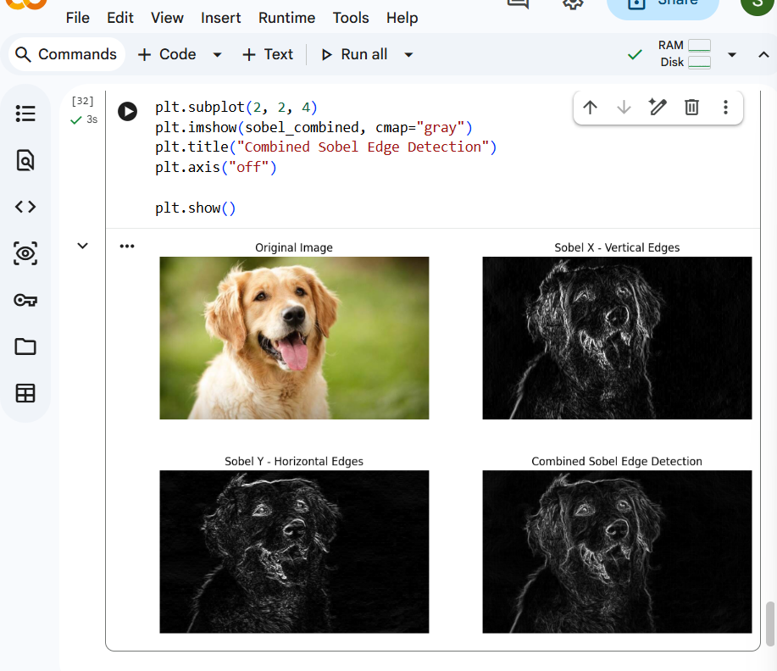

Experiment 17: Image Watermarking using OpenCV

from google.colab import files
uploaded = files.upload()

import cv2
import matplotlib.pyplot as plt

filename = list(uploaded.keys())[0]
image = cv2.imread(filename)
print("Image uploaded successfully:", filename)

watermarked_image = image.copy()

text = "SIMATS"

cv2.putText(
watermarked_image,
text,
(50, 100),
cv2.FONT_HERSHEY_SIMPLEX,
2,
(255, 255, 255),
3
)

plt.figure(figsize=(10, 5))

plt.subplot(1, 2, 1)
plt.imshow(cv2.cvtColor(image, cv2.COLOR_BGR2RGB))
plt.title("Original Image")
plt.axis("off")

plt.subplot(1, 2, 2)
plt.imshow(cv2.cvtColor(watermarked_image, cv2.COLOR_BGR2RGB))
plt.title("Watermarked Image")
plt.axis("off")

plt.show()

overlay = image.copy()

cv2.putText(
overlay,
"SIMATS",
(50, 100),
cv2.FONT_HERSHEY_SIMPLEX,
2,
(255, 255, 255),
3
)

watermarked_image = cv2.addWeighted(
overlay, 0.4,
image, 0.6,
0
)

plt.imshow(cv2.cvtColor(watermarked_image, cv2.COLOR_BGR2RGB))
plt.title("Transparent Watermark")
plt.axis("off")
plt.show()
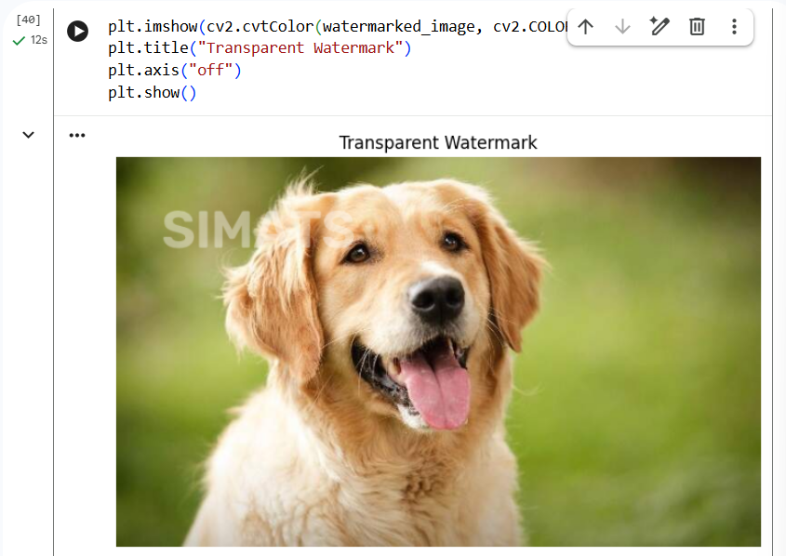

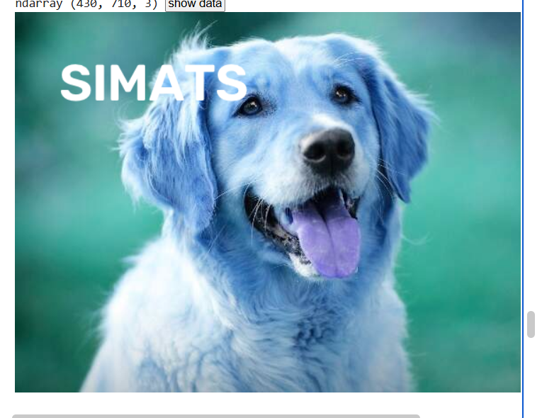

Exp 18
import cv2
import matplotlib.pyplot as plt

filename = list(uploaded.keys())[0]
image = cv2.imread(filename)

roi = image[50:200, 50:200]

result = image.copy()
result[200:350, 200:350] = roi

plt.figure(figsize=(12,4))
plt.subplot(1,3,1)
plt.imshow(cv2.cvtColor(image, cv2.COLOR_BGR2RGB))
plt.title("Original Image")
plt.axis("off")

plt.subplot(1,3,2)
plt.imshow(cv2.cvtColor(roi, cv2.COLOR_BGR2RGB))
plt.title("Cropped ROI")
plt.axis("off")

plt.subplot(1,3,3)
plt.imshow(cv2.cvtColor(result, cv2.COLOR_BGR2RGB))
plt.title("Copied and Pasted ROI")
plt.axis("off")

plt.show()
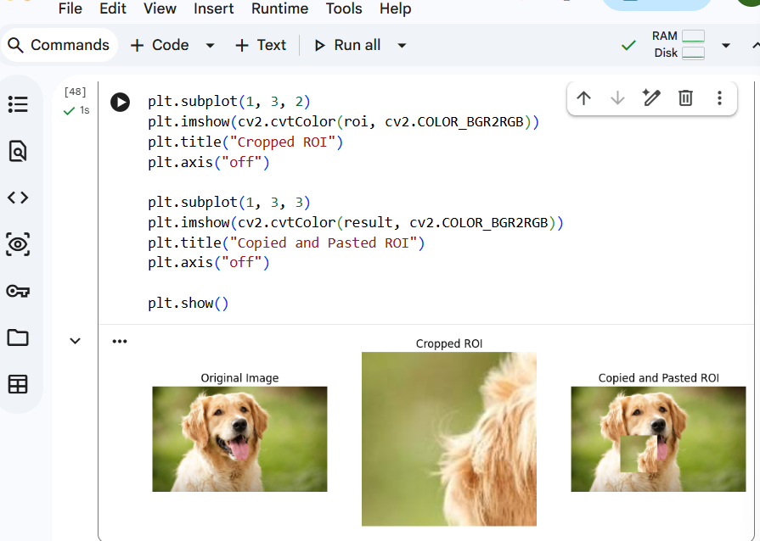

- Implement the Erosion Morphological operations technique using Open CV in python.
Erosion → shrinks white regions.
from google.colab import files
uploaded = files.upload()

import cv2
import numpy as np
import matplotlib.pyplot as plt

filename = list(uploaded.keys())[0]
image = cv2.imread(filename, 0)

kernel = np.ones((5,5), np.uint8)
eroded = cv2.erode(image, kernel, iterations=1)

plt.figure(figsize=(10,4))
plt.subplot(1,2,1)
plt.imshow(image, cmap="gray")
plt.title("Original Image")
plt.axis("off")
plt.subplot(1,2,2)
plt.imshow(eroded, cmap="gray")
plt.title("Eroded Image")
plt.axis("off")
plt.show()
20.Implement the Dilation technique as a Morphological operation to dilate the foreground regions based on Open CV.
Dilation → expands white regions.
from google.colab import files
uploaded = files.upload()

import cv2
import numpy as np
import matplotlib.pyplot as plt

filename = list(uploaded.keys())[0]
image = cv2.imread(filename, 0)
kernel = np.ones((5,5), np.uint8)
dilated = cv2.dilate(image, kernel, iterations=1)

plt.figure(figsize=(10,4))
plt.subplot(1,2,1)
plt.imshow(image, cmap="gray")
plt.title("Original Image")
plt.axis("off")
plt.subplot(1,2,2)
plt.imshow(dilated, cmap="gray")
plt.title("Dilated Image")
plt.axis("off")
plt.show()
